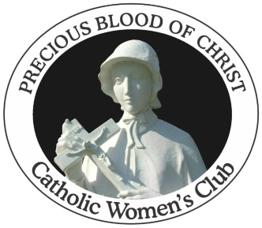 | PRECIOUS BLOOD OF CHRIST CATHOLIC WOMEN’S CLUB  _____________________________________________________________________  1633 Waverly Road  Pawleys Island, SC 29585

